%matplotlib inline ### import libraries import numpy as np import pandas as pd import matplotlib.pyplot as plt from matplotlib import style import seaborn as sns
In [2]:
data = pd.read_csv('health care diabetes.csv')
In [3]:
data.head()
Out[3]:
 | Pregnancies | Glucose | BloodPressure | SkinThickness | Insulin | BMI | DiabetesPedigreeFunction | Age | Outcome
0 | 6 | 148 | 72 | 35 | 0 | 33.6 | 0.627 | 50 | 1
1 | 1 | 85 | 66 | 29 | 0 | 26.6 | 0.351 | 31 | 0
2 | 8 | 183 | 64 | 0 | 0 | 23.3 | 0.672 | 32 | 1
3 | 1 | 89 | 66 | 23 | 94 | 28.1 | 0.167 | 21 | 0
4 | 0 | 137 | 40 | 35 | 168 | 43.1 | 2.288 | 33 | 1
In [4]:
data.isnull().any()
Out[4]:
Pregnancies False
Glucose False
BloodPressure False
SkinThickness False
Insulin False
BMI False
DiabetesPedigreeFunction False
Age False
Outcome False
dtype: bool
In [5]:
data.info()
<class 'pandas.core.frame.DataFrame'>
RangeIndex: 768 entries, 0 to 767
Data columns (total 9 columns):
Pregnancies 768 non-null int64
Glucose 768 non-null int64
BloodPressure 768 non-null int64
SkinThickness 768 non-null int64
Insulin 768 non-null int64
BMI 768 non-null float64
DiabetesPedigreeFunction 768 non-null float64
Age 768 non-null int64
Outcome 768 non-null int64
dtypes: float64(2), int64(7)
memory usage: 54.1 KB
In [41]:
Positive = data[data['Outcome']==1]
Positive.head(5)
Out[41]:
 | Pregnancies | Glucose | BloodPressure | SkinThickness | Insulin | BMI | DiabetesPedigreeFunction | Age | Outcome
0 | 6 | 148 | 72 | 35 | 0 | 33.6 | 0.627 | 50 | 1
2 | 8 | 183 | 64 | 0 | 0 | 23.3 | 0.672 | 32 | 1
4 | 0 | 137 | 40 | 35 | 168 | 43.1 | 2.288 | 33 | 1
6 | 3 | 78 | 50 | 32 | 88 | 31.0 | 0.248 | 26 | 1
8 | 2 | 197 | 70 | 45 | 543 | 30.5 | 0.158 | 53 | 1
In [43]:
data['Glucose'].value_counts().head(7)
Out[43]:
100 17
99 17
129 14
125 14
111 14
106 14
95 13
Name: Glucose, dtype: int64
In [35]:
plt.hist(data['Glucose'])
Out[35]:
(array([ 5., 0., 4., 32., 156., 211., 163., 95., 56., 46.]),
array([ 0. , 19.9, 39.8, 59.7, 79.6, 99.5, 119.4, 139.3, 159.2,
179.1, 199. ]),
<a list of 10 Patch objects>)
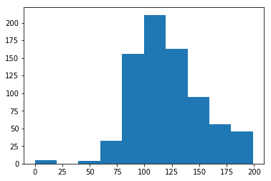
In [33]:
data['BloodPressure'].value_counts().head(7)
Out[33]:
70 57
74 52
68 45
78 45
72 44
64 43
80 40
Name: BloodPressure, dtype: int64
In [36]:
plt.hist(data['BloodPressure'])
Out[36]:
(array([ 35., 1., 2., 13., 107., 261., 243., 87., 14., 5.]),
array([ 0. , 12.2, 24.4, 36.6, 48.8, 61. , 73.2, 85.4, 97.6,
109.8, 122. ]),
<a list of 10 Patch objects>)
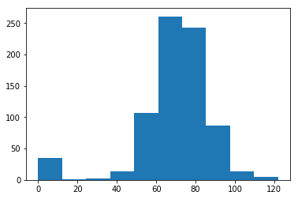
In [32]:
data['SkinThickness'].value_counts().head(7)
Out[32]:
0 227
32 31
30 27
27 23
23 22
33 20
18 20
Name: SkinThickness, dtype: int64
In [37]:
plt.hist(data['SkinThickness'])
Out[37]:
(array([231., 107., 165., 175., 78., 9., 2., 0., 0., 1.]),
array([ 0. , 9.9, 19.8, 29.7, 39.6, 49.5, 59.4, 69.3, 79.2, 89.1, 99. ]),
<a list of 10 Patch objects>)
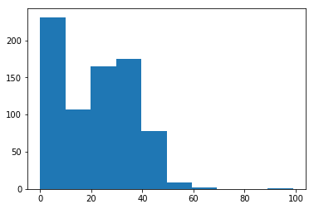
In [30]:
data['Insulin'].value_counts().head(7)
Out[30]:
0 374
105 11
140 9
130 9
120 8
100 7
94 7
Name: Insulin, dtype: int64
In [38]:
plt.hist(data['Insulin'])
Out[38]:
(array([487., 155., 70., 30., 8., 9., 5., 1., 2., 1.]),
array([ 0. , 84.6, 169.2, 253.8, 338.4, 423. , 507.6, 592.2, 676.8,
761.4, 846. ]),
<a list of 10 Patch objects>)
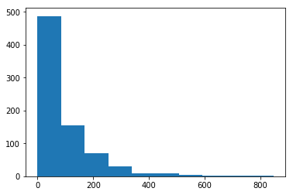
In [29]:
data['BMI'].value_counts().head(7)
Out[29]:
32.0 13
31.6 12
31.2 12
0.0 11
33.3 10
32.4 10
32.8 9
Name: BMI, dtype: int64
In [39]:
plt.hist(data['BMI'])
Out[39]:
(array([ 11., 0., 15., 156., 268., 224., 78., 12., 3., 1.]),
array([ 0. , 6.71, 13.42, 20.13, 26.84, 33.55, 40.26, 46.97, 53.68,
60.39, 67.1 ]),
<a list of 10 Patch objects>)
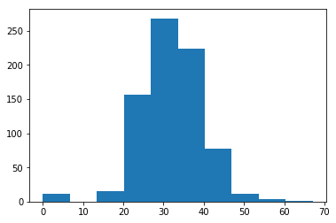
In [9]:
data.describe().transpose()
Out[9]:
 | count | mean | std | min | 25% | 50% | 75% | max
Pregnancies | 768.0 | 3.845052 | 3.369578 | 0.000 | 1.00000 | 3.0000 | 6.00000 | 17.00
Glucose | 768.0 | 120.894531 | 31.972618 | 0.000 | 99.00000 | 117.0000 | 140.25000 | 199.00
BloodPressure | 768.0 | 69.105469 | 19.355807 | 0.000 | 62.00000 | 72.0000 | 80.00000 | 122.00
SkinThickness | 768.0 | 20.536458 | 15.952218 | 0.000 | 0.00000 | 23.0000 | 32.00000 | 99.00
Insulin | 768.0 | 79.799479 | 115.244002 | 0.000 | 0.00000 | 30.5000 | 127.25000 | 846.00
BMI | 768.0 | 31.992578 | 7.884160 | 0.000 | 27.30000 | 32.0000 | 36.60000 | 67.10
DiabetesPedigreeFunction | 768.0 | 0.471876 | 0.331329 | 0.078 | 0.24375 | 0.3725 | 0.62625 | 2.42
Age | 768.0 | 33.240885 | 11.760232 | 21.000 | 24.00000 | 29.0000 | 41.00000 | 81.00
Outcome | 768.0 | 0.348958 | 0.476951 | 0.000 | 0.00000 | 0.0000 | 1.00000 | 1.00
In [ ]:

Week 2¶
In [49]:
plt.hist(Positive['BMI'],histtype='stepfilled',bins=20)
Out[49]:
(array([ 2., 0., 0., 0., 0., 0., 3., 13., 38., 61., 61., 36., 27.,
14., 7., 3., 1., 1., 0., 1.]),
array([ 0. , 3.355, 6.71 , 10.065, 13.42 , 16.775, 20.13 , 23.485,
26.84 , 30.195, 33.55 , 36.905, 40.26 , 43.615, 46.97 , 50.325,
53.68 , 57.035, 60.39 , 63.745, 67.1 ]),
<a list of 1 Patch objects>)
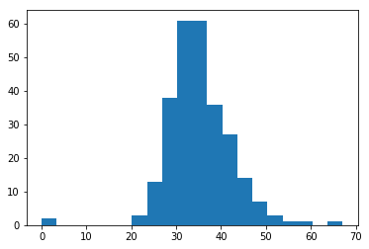
In [55]:
Positive['BMI'].value_counts().head(7)
Out[55]:
32.9 8
31.6 7
33.3 6
30.5 5
32.0 5
31.2 5
32.4 4
Name: BMI, dtype: int64
In [61]:
plt.hist(Positive['Glucose'],histtype='stepfilled',bins=20)
Out[61]:
(array([ 2., 0., 0., 0., 0., 0., 0., 1., 4., 9., 28., 26., 36.,
27., 29., 22., 24., 21., 25., 14.]),
array([ 0. , 9.95, 19.9 , 29.85, 39.8 , 49.75, 59.7 , 69.65,
79.6 , 89.55, 99.5 , 109.45, 119.4 , 129.35, 139.3 , 149.25,
159.2 , 169.15, 179.1 , 189.05, 199. ]),
<a list of 1 Patch objects>)
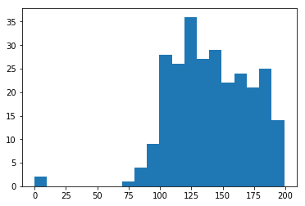
In [56]:
Positive['Glucose'].value_counts().head(7)
Out[56]:
125 7
158 6
128 6
115 6
129 6
146 5
162 5
Name: Glucose, dtype: int64
In [62]:
plt.hist(Positive['BloodPressure'],histtype='stepfilled',bins=20)
Out[62]:
(array([16., 0., 0., 0., 0., 1., 0., 1., 6., 6., 19., 37., 56.,
36., 41., 31., 7., 4., 4., 3.]),
array([ 0. , 5.7, 11.4, 17.1, 22.8, 28.5, 34.2, 39.9, 45.6,
51.3, 57. , 62.7, 68.4, 74.1, 79.8, 85.5, 91.2, 96.9,
102.6, 108.3, 114. ]),
<a list of 1 Patch objects>)
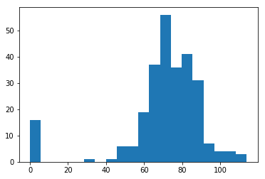
In [57]:
Positive['BloodPressure'].value_counts().head(7)
Out[57]:
70 23
76 18
78 17
74 17
72 16
0 16
82 13
Name: BloodPressure, dtype: int64
In [63]:
plt.hist(Positive['SkinThickness'],histtype='stepfilled',bins=20)
Out[63]:
(array([88., 1., 4., 10., 18., 30., 41., 34., 23., 15., 1., 1., 1.,
0., 0., 0., 0., 0., 0., 1.]),
array([ 0. , 4.95, 9.9 , 14.85, 19.8 , 24.75, 29.7 , 34.65, 39.6 ,
44.55, 49.5 , 54.45, 59.4 , 64.35, 69.3 , 74.25, 79.2 , 84.15,
89.1 , 94.05, 99. ]),
<a list of 1 Patch objects>)
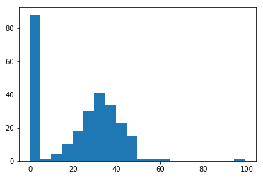
In [60]:
Positive['SkinThickness'].value_counts().head(7)
Out[60]:
0 88
32 14
33 9
30 9
39 8
35 8
36 8
Name: SkinThickness, dtype: int64
In [64]:
plt.hist(Positive['Insulin'],histtype='stepfilled',bins=20)
Out[64]:
(array([141., 6., 23., 33., 24., 12., 7., 7., 2., 1., 1.,
5., 3., 1., 1., 0., 0., 0., 0., 1.]),
array([ 0. , 42.3, 84.6, 126.9, 169.2, 211.5, 253.8, 296.1, 338.4,
380.7, 423. , 465.3, 507.6, 549.9, 592.2, 634.5, 676.8, 719.1,
761.4, 803.7, 846. ]),
<a list of 1 Patch objects>)
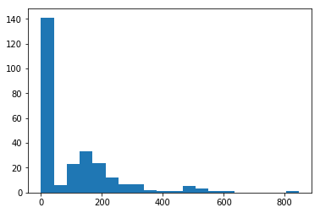
In [59]:
Positive['Insulin'].value_counts().head(7)
Out[59]:
0 138
130 6
180 4
156 3
175 3
194 2
125 2
Name: Insulin, dtype: int64
In [65]:
#Scatter plot
In [68]:
BloodPressure = Positive['BloodPressure']
Glucose = Positive['Glucose']
SkinThickness = Positive['SkinThickness']
Insulin = Positive['Insulin']
BMI = Positive['BMI']
In [85]:
plt.scatter(BloodPressure, Glucose, color=['b'])
plt.xlabel('BloodPressure')
plt.ylabel('Glucose')
plt.title('BloodPressure & Glucose')
plt.show()
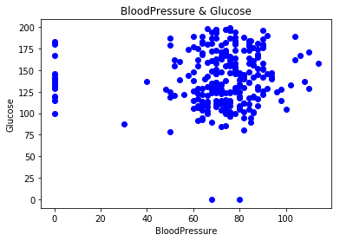
In [101]:
g =sns.scatterplot(x= "Glucose" ,y= "BloodPressure",
hue="Outcome",
data=data);
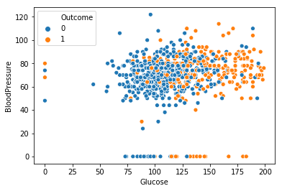
In [100]:
B =sns.scatterplot(x= "BMI" ,y= "Insulin",
hue="Outcome",
data=data);
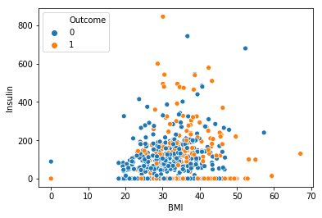
In [107]:
S =sns.scatterplot(x= "SkinThickness" ,y= "Insulin",
hue="Outcome",
data=data);
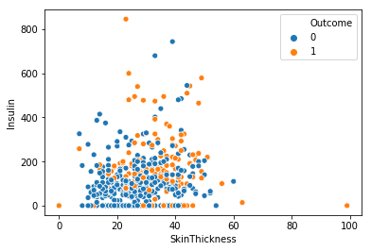
In [104]:
### correlation matrix
data.corr()
Out[104]:
 | Pregnancies | Glucose | BloodPressure | SkinThickness | Insulin | BMI | DiabetesPedigreeFunction | Age | Outcome
Pregnancies | 1.000000 | 0.129459 | 0.141282 | -0.081672 | -0.073535 | 0.017683 | -0.033523 | 0.544341 | 0.221898
Glucose | 0.129459 | 1.000000 | 0.152590 | 0.057328 | 0.331357 | 0.221071 | 0.137337 | 0.263514 | 0.466581
BloodPressure | 0.141282 | 0.152590 | 1.000000 | 0.207371 | 0.088933 | 0.281805 | 0.041265 | 0.239528 | 0.065068
SkinThickness | -0.081672 | 0.057328 | 0.207371 | 1.000000 | 0.436783 | 0.392573 | 0.183928 | -0.113970 | 0.074752
Insulin | -0.073535 | 0.331357 | 0.088933 | 0.436783 | 1.000000 | 0.197859 | 0.185071 | -0.042163 | 0.130548
BMI | 0.017683 | 0.221071 | 0.281805 | 0.392573 | 0.197859 | 1.000000 | 0.140647 | 0.036242 | 0.292695
DiabetesPedigreeFunction | -0.033523 | 0.137337 | 0.041265 | 0.183928 | 0.185071 | 0.140647 | 1.000000 | 0.033561 | 0.173844
Age | 0.544341 | 0.263514 | 0.239528 | -0.113970 | -0.042163 | 0.036242 | 0.033561 | 1.000000 | 0.238356
Outcome | 0.221898 | 0.466581 | 0.065068 | 0.074752 | 0.130548 | 0.292695 | 0.173844 | 0.238356 | 1.000000
In [105]:
### create correlation heat map
sns.heatmap(data.corr())
Out[105]:
<matplotlib.axes._subplots.AxesSubplot at 0x2278a586278>
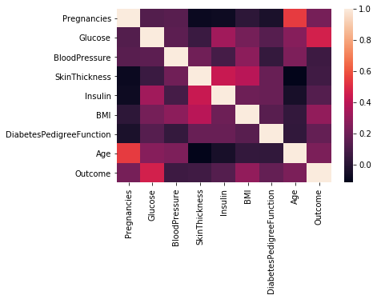
In [106]:
plt.subplots(figsize=(8,8))
sns.heatmap(data.corr(),annot=True,cmap='viridis') ### gives correlation value
Out[106]:
<matplotlib.axes._subplots.AxesSubplot at 0x2278a71d710>
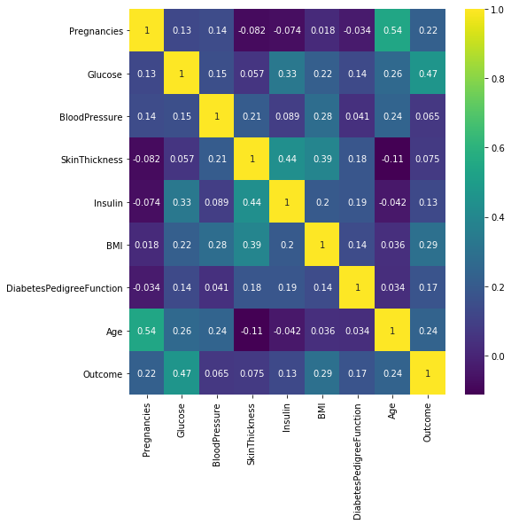
In [116]:
plt.subplots(figsize=(8,8))
sns.heatmap(data.corr(),annot=True) ### gives correlation value
Out[116]:
<matplotlib.axes._subplots.AxesSubplot at 0x2278bde9f28>
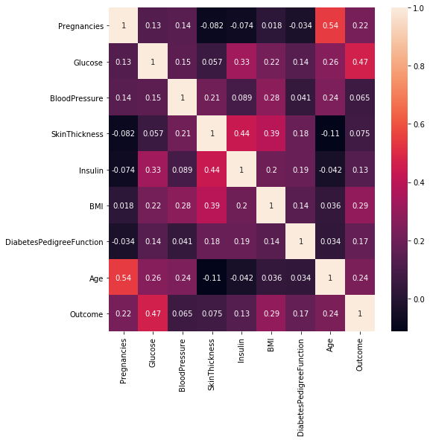
In [113]:
# Logistic Regreation and model building
In [117]:
data.head(5)
Out[117]:
 | Pregnancies | Glucose | BloodPressure | SkinThickness | Insulin | BMI | DiabetesPedigreeFunction | Age | Outcome
0 | 6 | 148 | 72 | 35 | 0 | 33.6 | 0.627 | 50 | 1
1 | 1 | 85 | 66 | 29 | 0 | 26.6 | 0.351 | 31 | 0
2 | 8 | 183 | 64 | 0 | 0 | 23.3 | 0.672 | 32 | 1
3 | 1 | 89 | 66 | 23 | 94 | 28.1 | 0.167 | 21 | 0
4 | 0 | 137 | 40 | 35 | 168 | 43.1 | 2.288 | 33 | 1
In [130]:
features = data.iloc[:,[0,1,2,3,4,5,6,7]].values
label = data.iloc[:,8].values
In [136]:
#Train test split
from sklearn.model_selection import train_test_split
X_train,X_test,y_train,y_test = train_test_split(features,
label,
test_size=0.2,
random_state =10)
In [137]:
#Create model
from sklearn.linear_model import LogisticRegression
model = LogisticRegression()
model.fit(X_train,y_train)
C:\ProgramData\Anaconda3\lib\site-packages\sklearn\linear_model\logistic.py:433: FutureWarning: Default solver will be changed to 'lbfgs' in 0.22. Specify a solver to silence this warning.
FutureWarning)
Out[137]:
LogisticRegression(C=1.0, class_weight=None, dual=False, fit_intercept=True,
intercept_scaling=1, max_iter=100, multi_class='warn',
n_jobs=None, penalty='l2', random_state=None, solver='warn',
tol=0.0001, verbose=0, warm_start=False)
In [138]:
print(model.score(X_train,y_train))
print(model.score(X_test,y_test))
0.7833876221498371
0.7337662337662337
In [139]:
from sklearn.metrics import confusion_matrix
cm = confusion_matrix(label,model.predict(features))
cm
Out[139]:
array([[452, 48],
[126, 142]], dtype=int64)
In [140]:
from sklearn.metrics import classification_report
print(classification_report(label,model.predict(features)))
precision recall f1-score support

0 0.78 0.90 0.84 500
1 0.75 0.53 0.62 268

micro avg 0.77 0.77 0.77 768
macro avg 0.76 0.72 0.73 768
weighted avg 0.77 0.77 0.76 768

In [141]:
#Preparing ROC Curve (Receiver Operating Characteristics Curve)
from sklearn.metrics import roc_curve
from sklearn.metrics import roc_auc_score

# predict probabilities
probs = model.predict_proba(features)
# keep probabilities for the positive outcome only
probs = probs[:, 1]
# calculate AUC
auc = roc_auc_score(label, probs)
print('AUC: %.3f' % auc)
# calculate roc curve
fpr, tpr, thresholds = roc_curve(label, probs)
# plot no skill
plt.plot([0, 1], [0, 1], linestyle='--')
# plot the roc curve for the model
plt.plot(fpr, tpr, marker='.')
AUC: 0.834
Out[141]:
[<matplotlib.lines.Line2D at 0x2278c4fba90>]
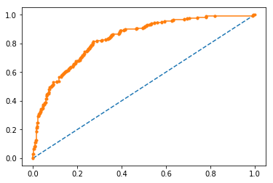
In [152]:
#Applying Decission Tree Classifier
from sklearn.tree import DecisionTreeClassifier
model3 = DecisionTreeClassifier(max_depth=5)
model3.fit(X_train,y_train)
Out[152]:
DecisionTreeClassifier(class_weight=None, criterion='gini', max_depth=5,
max_features=None, max_leaf_nodes=None,
min_impurity_decrease=0.0, min_impurity_split=None,
min_samples_leaf=1, min_samples_split=2,
min_weight_fraction_leaf=0.0, presort=False, random_state=None,
splitter='best')
In [163]:
model3.score(X_train,y_train)
Out[163]:
0.990228013029316
In [164]:
model3.score(X_test,y_test)
Out[164]:
0.7532467532467533
In [162]:
#Applying Random Forest
from sklearn.ensemble import RandomForestClassifier
model4 = RandomForestClassifier(n_estimators=11)
model4.fit(X_train,y_train)
Out[162]:
RandomForestClassifier(bootstrap=True, class_weight=None, criterion='gini',
max_depth=None, max_features='auto', max_leaf_nodes=None,
min_impurity_decrease=0.0, min_impurity_split=None,
min_samples_leaf=1, min_samples_split=2,
min_weight_fraction_leaf=0.0, n_estimators=11, n_jobs=None,
oob_score=False, random_state=None, verbose=0,
warm_start=False)
In [165]:
model4.score(X_train,y_train)
Out[165]:
0.990228013029316
In [166]:
model4.score(X_test,y_test)
Out[166]:
0.7532467532467533
In [169]:
#Support Vector Classifier

from sklearn.svm import SVC
model5 = SVC(kernel='rbf',
gamma='auto')
model5.fit(X_train,y_train)
Out[169]:
SVC(C=1.0, cache_size=200, class_weight=None, coef0=0.0,
decision_function_shape='ovr', degree=3, gamma='auto', kernel='rbf',
max_iter=-1, probability=False, random_state=None, shrinking=True,
tol=0.001, verbose=False)
In [170]:
model5model.score(X_test,y_test).score(X_train,y_train)
Out[170]:
1.0
In [171]:
model5.score(X_test,y_test)
Out[171]:
0.6168831168831169
In [142]:
#Applying K-NN
from sklearn.neighbors import KNeighborsClassifier
model2 = KNeighborsClassifier(n_neighbors=7,
metric='minkowski',
p = 2)
model2.fit(X_train,y_train)
Out[142]:
KNeighborsClassifier(algorithm='auto', leaf_size=30, metric='minkowski',
metric_params=None, n_jobs=None, n_neighbors=7, p=2,
weights='uniform')
In [143]:
#Preparing ROC Curve (Receiver Operating Characteristics Curve)
from sklearn.metrics import roc_curve
from sklearn.metrics import roc_auc_score

# predict probabilities
probs = model2.predict_proba(features)
# keep probabilities for the positive outcome only
probs = probs[:, 1]
# calculate AUC
auc = roc_auc_score(label, probs)
print('AUC: %.3f' % auc)
# calculate roc curve
fpr, tpr, thresholds = roc_curve(label, probs)
print("True Positive Rate - {}, False Positive Rate - {} Thresholds - {}".format(tpr,fpr,thresholds))
# plot no skill
plt.plot([0, 1], [0, 1], linestyle='--')
# plot the roc curve for the model
plt.plot(fpr, tpr, marker='.')
plt.xlabel("False Positive Rate")
plt.ylabel("True Positive Rate")
AUC: 0.836
True Positive Rate - [0. 0.06716418 0.23880597 0.44776119 0.60074627 0.75373134
0.88059701 0.98507463 1. ], False Positive Rate - [0. 0. 0.02 0.056 0.12 0.248 0.428 0.668 1. ] Thresholds - [2. 1. 0.85714286 0.71428571 0.57142857 0.42857143
0.28571429 0.14285714 0. ]
Out[143]:
Text(0, 0.5, 'True Positive Rate')
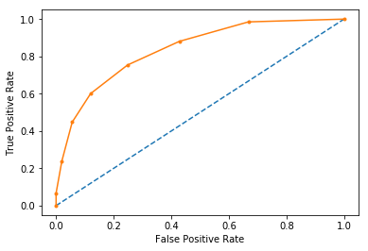
In [144]:
#Precision Recall Curve for Logistic Regression

from sklearn.metrics import precision_recall_curve
from sklearn.metrics import f1_score
from sklearn.metrics import auc
from sklearn.metrics import average_precision_score
# predict probabilities
probs = model.predict_proba(features)
# keep probabilities for the positive outcome only
probs = probs[:, 1]
# predict class values
yhat = model.predict(features)
# calculate precision-recall curve
precision, recall, thresholds = precision_recall_curve(label, probs)
# calculate F1 score
f1 = f1_score(label, yhat)
# calculate precision-recall AUC
auc = auc(recall, precision)
# calculate average precision score
ap = average_precision_score(label, probs)
print('f1=%.3f auc=%.3f ap=%.3f' % (f1, auc, ap))
# plot no skill
plt.plot([0, 1], [0.5, 0.5], linestyle='--')
# plot the precision-recall curve for the model
plt.plot(recall, precision, marker='.')
f1=0.620 auc=0.728 ap=0.728
Out[144]:
[<matplotlib.lines.Line2D at 0x2278d0052e8>]
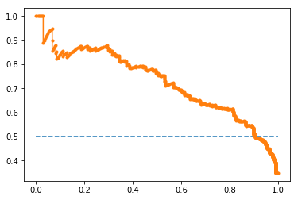
In [145]:
#Precision Recall Curve for KNN

from sklearn.metrics import precision_recall_curve
from sklearn.metrics import f1_score
from sklearn.metrics import auc
from sklearn.metrics import average_precision_score
# predict probabilities
probs = model2.predict_proba(features)
# keep probabilities for the positive outcome only
probs = probs[:, 1]
# predict class values
yhat = model2.predict(features)
# calculate precision-recall curve
precision, recall, thresholds = precision_recall_curve(label, probs)
# calculate F1 score
f1 = f1_score(label, yhat)
# calculate precision-recall AUC
auc = auc(recall, precision)
# calculate average precision score
ap = average_precision_score(label, probs)
print('f1=%.3f auc=%.3f ap=%.3f' % (f1, auc, ap))
# plot no skill
plt.plot([0, 1], [0.5, 0.5], linestyle='--')
# plot the precision-recall curve for the model
plt.plot(recall, precision, marker='.')
f1=0.658 auc=0.752 ap=0.709
Out[145]:
[<matplotlib.lines.Line2D at 0x2278d025908>]
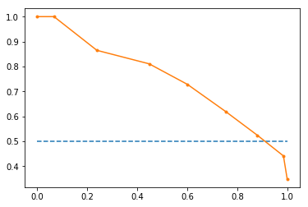
In [167]:
#Precision Recall Curve for Decission Tree Classifier

from sklearn.metrics import precision_recall_curve
from sklearn.metrics import f1_score
from sklearn.metrics import auc
from sklearn.metrics import average_precision_score
# predict probabilities
probs = model3.predict_proba(features)
# keep probabilities for the positive outcome only
probs = probs[:, 1]
# predict class values
yhat = model3.predict(features)
# calculate precision-recall curve
precision, recall, thresholds = precision_recall_curve(label, probs)
# calculate F1 score
f1 = f1_score(label, yhat)
# calculate precision-recall AUC
auc = auc(recall, precision)
# calculate average precision score
ap = average_precision_score(label, probs)
print('f1=%.3f auc=%.3f ap=%.3f' % (f1, auc, ap))
# plot no skill
plt.plot([0, 1], [0.5, 0.5], linestyle='--')
# plot the precision-recall curve for the model
plt.plot(recall, precision, marker='.')
f1=0.916 auc=0.966 ap=0.958
Out[167]:
[<matplotlib.lines.Line2D at 0x2278bde2a20>]
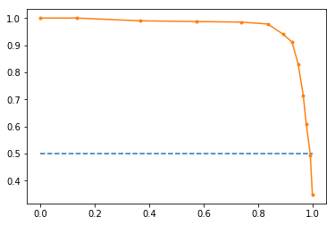
In [168]:
#Precision Recall Curve for Random Forest

from sklearn.metrics import precision_recall_curve
from sklearn.metrics import f1_score
from sklearn.metrics import auc
from sklearn.metrics import average_precision_score
# predict probabilities
probs = model4.predict_proba(features)
# keep probabilities for the positive outcome only
probs = probs[:, 1]
# predict class values
yhat = model4.predict(features)
# calculate precision-recall curve
precision, recall, thresholds = precision_recall_curve(label, probs)
# calculate F1 score
f1 = f1_score(label, yhat)
# calculate precision-recall AUC
auc = auc(recall, precision)
# calculate average precision score
ap = average_precision_score(label, probs)
print('f1=%.3f auc=%.3f ap=%.3f' % (f1, auc, ap))
# plot no skill
plt.plot([0, 1], [0.5, 0.5], linestyle='--')
# plot the precision-recall curve for the model
plt.plot(recall, precision, marker='.')
f1=0.914 auc=0.968 ap=0.960
Out[168]:
[<matplotlib.lines.Line2D at 0x2278a747cf8>]
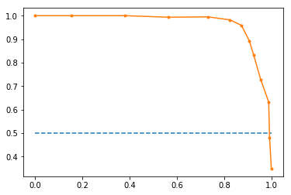
In [ ]:

